# **Project Setup**

In this session, we setup our project on GitHub. So please fallow below recipes for the same.

**Recipe1: Signing up for a new GitHub account (If Not)**

GitHub offers free accounts for users and organizations working on public and open source projects, as well as paid accounts that offer unlimited private repositories and optional user management and security features.

**Signing up for service**

Go to GitHub's Pricing page.

Read the information about the different accounts and plans that GitHub offers.

Sign up for an account on the free plan, click Sign up for one of free plans.

Follow the prompts to create your personal account and optionally, upgrade your personal account or create and upgrade an organization account.

Verify your email address

**Recipe2: Creating a new repository**

In the upper-right corner of any page, click, and then click **New repository**.

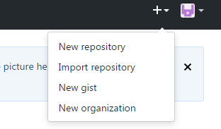

In the Owner drop-down, select the account you wish to create the repository on.

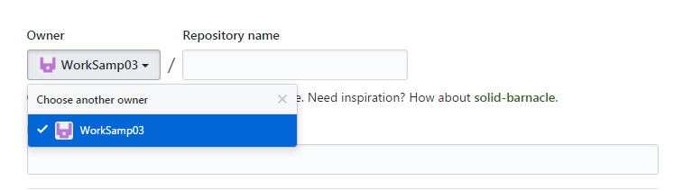

Type a name for your repository, and an optional description.

You can choose to make the repository either public or private. Public repositories are visible to the public, while private repositories are only accessible to you, and people you share them with. Your account must be on a paid plan to create a private repository.

Choose **Public** one and click Create repository.

At the bottom of the resulting Quick Setup page, under "Import code from an old repository", you can choose to import a project to your new repository. To do so, click Import code.

In the url box type below line

<https://github.com/worksamp/MeanStack> and click on Begin import button

